 | The Islamia University of Bahawalpur  Department of Information Technology  Software Design Documentation (SDD)  ElevatedCRM-A Customer Relationship Management System | 

Submitted By:
Name | Roll No | Role | Session
Muneeba Arshad | F22BINFT1M01093 | Front-end Developer | 2022-2026
Noor Ul Huda | F22BINFT1M01090 | Back-end Developer | 2022-2026
Submitted To:
Sir Muzammil Ur Rehman

Summary
This Software Design Document presents the detailed design of ElevatedCRM, a web-based Customer Relationship Management system developed as a Final Year Project. The system is designed to centralize customer information, sales leads, products, and activity records to improve business efficiency and data management.
ElevatedCRM supports multiple user roles, enabling sales staff and administrators to perform tasks based on assigned permissions. The system follows the Model–View–Controller (MVC) architecture, which separates user interface, business logic, and data processing to improve system maintainability and scalability.
The document describes major system modules such as authentication, user and role management, lead management, contact management, product management, and activity tracking. The database design uses a relational approach to ensure data integrity and structured relationships.
System workflows, security features, and performance considerations are discussed to ensure reliable operation. The document also highlights potential future enhancements for system expansion.
Overall, this SDD serves as a comprehensive technical guide for the development and maintenance of ElevatedCRM.

Table of Contents
- Introduction
- System Overview
- Design Goals and Objectives
- System Architecture
4.1 Architectural Style
4.2 Application Layers
4.2.1 Presentation Layer
4.2.2 Application Layer
4.2.3 Data Layer
- Module Design
5.1 Authentication Module
5.2 User and Role Management Module
5.3 Lead Management Module
5.4 Contact and Organization Module
5.5 Product Management Module
5.6 Activity Management Module
- Data Design
6.1 Database Design Approach
6.2 Main Database Tables
6.3 Relationships
- System Workflow
- User Interface Design
- Error Handling and Validation
- Security Design
- Performance Considerations
- Future Enhancements
- Conclusion

SOFTWARE DESIGN DOCUMENT (SDD)

ElevatedCRM – Customer Relationship Management System

1. Introduction
This Software Design Document (SDD) describes the internal design of ElevatedCRM, a web-based Customer Relationship Management system developed as a Final Year Project. The purpose of this document is to explain how the system is designed, how its components interact, and how functional requirements are translated into a working system.
This document focuses on system architecture, module design, database structure, workflows, and user interface design. It provides enough detail to understand system behavior and to support future development or maintenance.

2. System Overview
ElevatedCRM is designed to help organizations manage customer information, sales leads, products, and related activities in a centralized system. Instead of maintaining data manually or across multiple tools, ElevatedCRM provides a unified platform where users can track customer interactions and sales progress efficiently.
The system supports multiple users with different access levels. Sales staff can manage leads and activities, while administrators can manage users, roles, and system settings. The system is designed to be modular, allowing features to be extended in the future if required.

3. Design Goals and Objectives
The main objectives behind the design of ElevatedCRM are:
- To provide a clear and easy-to-use interface
- To ensure secure access using role-based permissions
- To maintain clean separation between system components
- To support scalability for future feature enhancements
- To reduce manual work and improve data accuracy
- To allow quick access to customer and sales information
ID | Requirement | Priority
FR-A.01 | The system shall allow users to create and manage Activities (Meetings, Calls, Notes). | High
FR-A.02 | Activities shall be linked to a specific Lead, Person, or Organization. | High
FR-A.03 | The system shall integrate with an email service to track and log all customer email interactions against the corresponding contact record. | High
FR-A.04 | The system shall provide a central view of all upcoming and past Activities. | High

System Architecture

4.1 Architectural Style
ElevatedCRM follows the Model–View–Controller (MVC) architectural pattern.
- Model handles data logic and database interaction
- View manages user interface and data presentation
- Controller processes user requests and applies business logic
This separation improves maintainability, readability, and debugging.

4.2 Application Layers

Presentation Layer
This layer handles user interaction. It includes all user interface components such as forms, dashboards, tables, and buttons. It ensures a smooth and responsive user experience.

Application Layer
This layer contains business logic. It processes requests, validates data, and coordinates between the presentation and data layers.

Data Layer

This layer handles database operations such as storing, retrieving, updating, and deleting records.
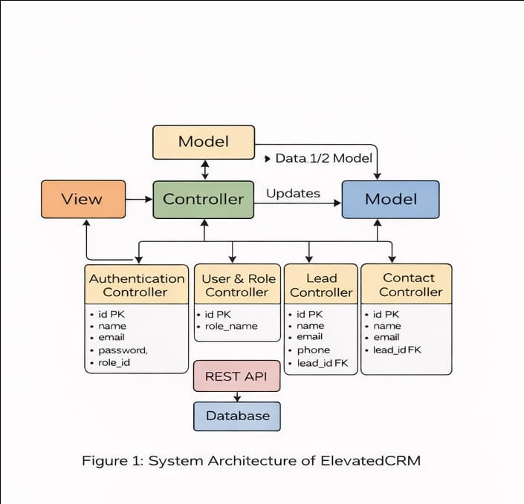

5. Module Design

5.1 Authentication Module
The authentication module manages user login and logout functionality. It verifies user credentials and maintains session data. Only authenticated users can access system features.
Key functions:
- User login
- User logout
- Session handling

5.2 User and Role Management Module
This module allows administrators to create users and assign roles. Each role defines specific permissions, such as viewing records, creating data, or deleting information.
Key functions:
- Create and manage users
- Assign roles
- Restrict access based on permissions
User Role | Description | Key System Interactions
Administrator | System configuration, user management, security, and customization. | ACL configuration, User CRUD operations, Custom Field setup, full data oversight.
Sales Manager | Team oversight, pipeline monitoring, performance tracking, and lead assignment. | Dashboard viewing, Kanban analysis, Opportunity funnel reporting.
Sales Agent | Daily customer interaction, data input, and activity execution. | Lead/Opportunity creation, updating contact records, Activities scheduling, email tracking.

5.3 Lead Management Module
The lead management module is responsible for handling sales leads. Users can create new leads, update existing ones, and track lead progress through different stages.
Key functions:
- Add and update leads
- Change lead status (open, won, lost)
- View lead history
ID | Requirement | Priority
FR-L.01 | The system shall allow users to create, view, edit, and delete Lead records. | High
FR-L.02 | The system shall provide a Kanban View to visually organize Leads based on their sales stages. | High
FR-L.03 | Users shall be able to drag-and-drop Leads between stages in the Kanban View. | High
FR-L.04 | The system shall allow Leads to be marked as "Won" or "Lost," converting them into Opportunities. | High
FR-L.05 | Each Opportunity shall be associated with an Expected Revenue value. | High

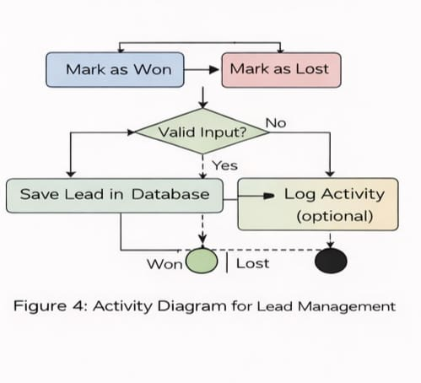

5.4 Contact and Organization Module
This module manages detailed information about individuals and organizations associated with leads. It helps maintain accurate customer records.
Key functions:
- Manage contacts
- Manage organizations
- Link contacts to leads
ID | Requirement | Priority
FR-C.01 | The system shall allow the creation and management of two primary entities: Persons and Organizations. | High
FR-C.02 | Person records shall include contact details, associated Organization, and a history of all interactions (calls, emails, meetings). | High
FR-C.03 | Organization records shall list all associated Person contacts and a consolidated history of interactions. | High

5.5 Product Management Module
This module manages products or services offered by the organization. Products can be linked to leads to analyze sales performance.
Key functions:
- Add and update products
- Associate products with leads
- Track product usage in sales

5.6 Activity Management Module
The activity management module records interactions such as meetings, calls, and notes. Activities are linked to leads to maintain communication history.
Key functions:
- Log activities
- Update or delete activities
- View activity timeline

6. Data Design

6.1 Database Design Approach
ElevatedCRM uses a relational database design. Data is organized into tables, and relationships are maintained using primary and foreign keys. This approach ensures data integrity and avoids duplication.

6.2 Main Database Tables
- Users – Stores user information
- Roles – Defines access permissions
- Leads – Stores lead data
- Contacts – Stores customer information
- Organizations – Stores company details
- Products – Stores product information
- Activities – Stores meetings, calls, and notes

6.3 Relationships
- One user belongs to one role
- One lead can have multiple activities
- One lead can be linked to multiple contacts
- Products can be associated with leads
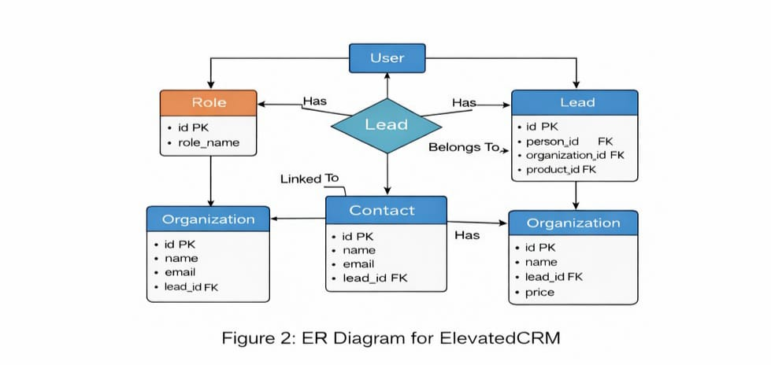

7. System Workflow
- User logs into the system
- Dashboard displays system overview
- User creates or updates leads
- Contacts and products are linked to leads
- Activities are recorded against lead
- Lead status is updated until completion
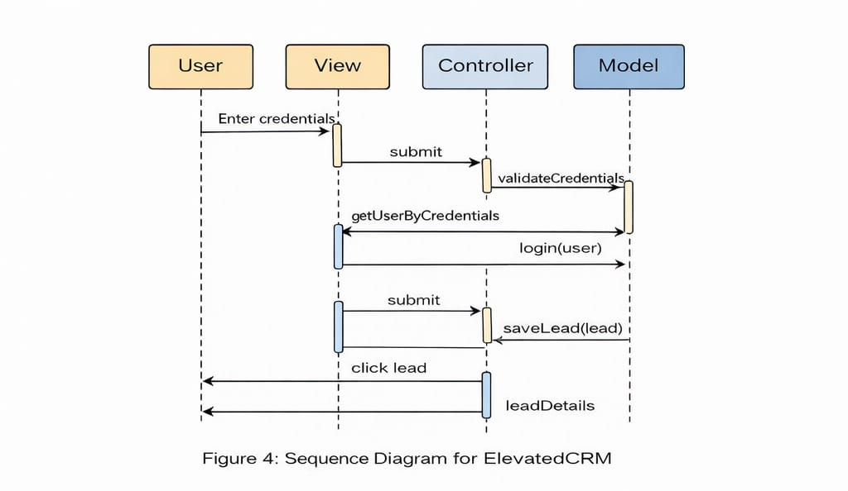

8. User Interface Design
The user interface of ElevatedCRM is designed to be simple and professional. A clean layout and consistent navigation are used to reduce user effort.
ID | Requirement | Priority
FR-D.01 | The system shall display a real-time dashboard showing key metrics (e.g., total sales, pipeline value). | High
FR-D.02 | The dashboard shall include widgets for new Leads, upcoming Activities, Customers, and Products. | High
FR-D.03 | The dashboard shall reflect updated metrics upon lead conversion (won/lost) in real-time. | High

Main Screens
- Login Screen
- Dashboard
- Lead Management
- Contact Management
- Product Management
- Activity Management
- User & Role Management
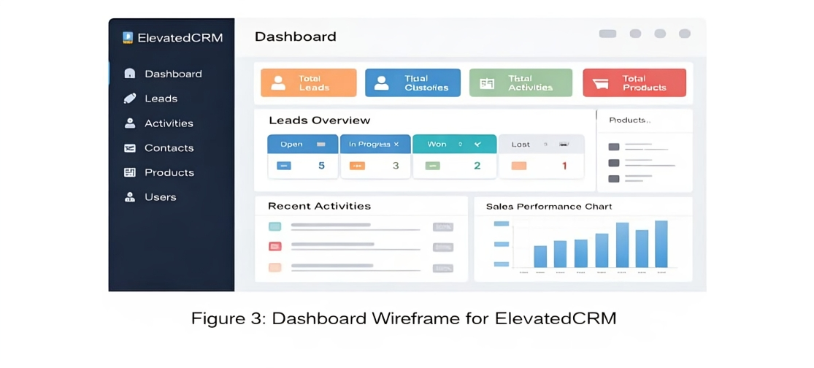
Name | FR001
Purpose | Sign up process is required for a user to become a verified member of the system with an assigned role.
User(s) | Administrator (Creates and approves), New Sales Agent, Sales Manager
Input | Name: Actual name of user. Email: Unique email address. Password: Must be 8 characters long and include numbers and special characters. Address: Actual residence address. Phone: Working phone number. Display Picture: Latest face picture.
Output | User record is created with a 'Pending' status. The user will be notified of pending approval.
Approval from Super User | A designated Superuser (Administrator) will verify the information and manually set the status of the user to 'Active' and assign a specific Role (e.g., 'Sales Agent').
User(s) | Sales Agent, Sales Manager
Input | Lead Name, Email, Phone, Initial Stage, Expected Close Date, Expected Revenue. Custom fields as configured by the Administrator.
Name | FR003
Purpose | To transition a qualified lead into a final outcome, updating financial metrics and converting the lead into a permanent customer.
User(s) | Sales Agent
Input | Opportunity Status (Won/Lost). If Won: Final Sale Amount.
Output | If Won: Lead record is closed, a new permanent Contact/Customer and Organization record is created, and the Dashboard's revenue metrics are incremented. If Lost: Lead record is archived, and pipeline metrics are updated.

9. Error Handling and Validation
Input validation is applied on all forms to ensure data accuracy. Mandatory fields must be completed before submission. Error messages guide users when incorrect or incomplete data is entered.

10. Security Design
Security is handled using authentication and authorization mechanisms. Role-based access ensures users can only access permitted features. Sensitive actions are restricted to authorized users.

11. Performance Considerations
The system is designed to handle multiple users efficiently. Database queries are optimized, and unnecessary data loading is avoided to ensure fast response times.

12. Future Enhancements
Future improvements may include:
- Advanced reporting features
- Email notifications
- Mobile optimization
- Improved analytics dashboards

13. Conclusion
This Software Design Document provides a detailed explanation of the design and structure of ElevatedCRM. The modular architecture, secure access control, and clear workflows make the system reliable and maintainable. The design supports future expansion while fulfilling current project requirements.

